Overlap Issues

Using November WDPA filtered data as given by Birdlife

September KBA Data

Most issues are resolved, but I’m still seeing some discrepancies in coverage in some areas. Here are some examples

**Germany. KBA SitRecID == 3335**

Purple is PA, Orange outline is KBA



My run has this KBA as 99.4% coverage, and theirs was 59.2

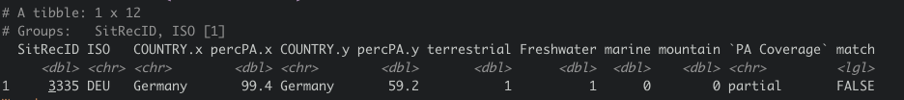

There are 12 PAs that are identified as intersecting this KBA (see pac_example.csv)

This part of the code (finding and calculating the intersection) I haven’t touched at all, so my assumption would have to be something about the input files is still off, but I’m out of ideas for what it could be.

(Filled in orange outline for clarity next page)



South Africa SitRecID == 45542





I got 7.3%, they got 1.1%

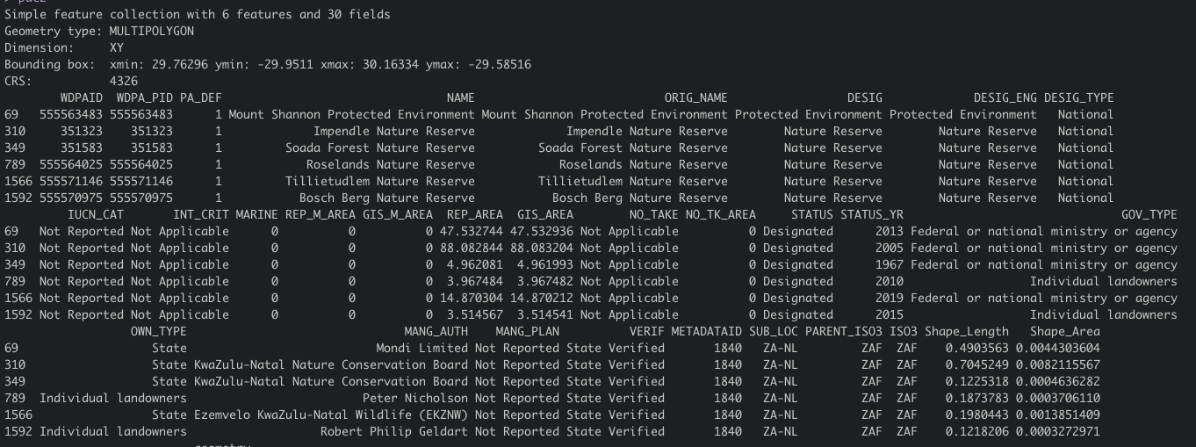

6 PAs overlapping

South Africa SitRecID = 7110





I got 44.1, they got 48